+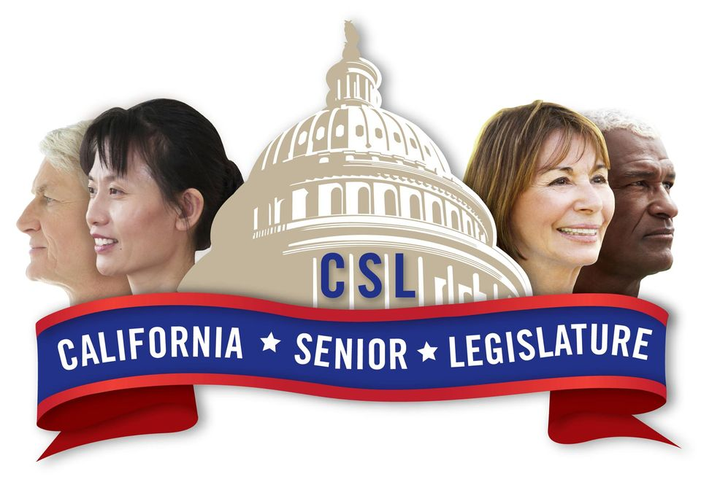
APPLICATION FOR CSL CANDIDACY

PSA ______ Incumbent ___ New Candidate ___

Name of Candidate: ___________________________________________________________

Address: ____________________________________________________________________

City & Zip: ___________________________________________________________________

Telephone(s) (Home)_________________________(CP) _____________________________

Email: ______________________________________________________________________

My State Senator is: ____________________________________________ District # ______

My State Assembly member is: ___________________________________ District # ______

My Congressional Representative is: _______________________________ District # ______

For the Office of ________________________________________ I certify that
(Senior Senator/Senior Assemblymember)

- I am 55 years of age on election day.
      - I am a registered voter.
      - I reside in the Planning and Service Area (PSA) for which the election is held.
- I own a functioning computer and a printer.
- I have the ability to scan and email documents, as needed.
      - I have a personal email account and basic access to and knowledge of how to
use email, transmit documents, open MSOffice and PDF documents, utilize electronic drop boxes, complete Google Forms and participate in virtual meetings utilizing Zoom.
      - I possess the ability to take top senior concerns/issues at local level and draft them
into a legislative proposal following a template.

I agree that all decisions regarding my candidacy, election and/or recall are the responsibility of the CSL JRC and are final and binding.

Signature ____________________________________________ Date Signed __________

Attach the following documents to this application:

      - Resume outlining broad base of experience at the city and county levels on issues
dealing with seniors
      - Signed Code of Ethics
      - Signed Volunteer Agreement and Waiver
      - Signed Statement of Commitment

