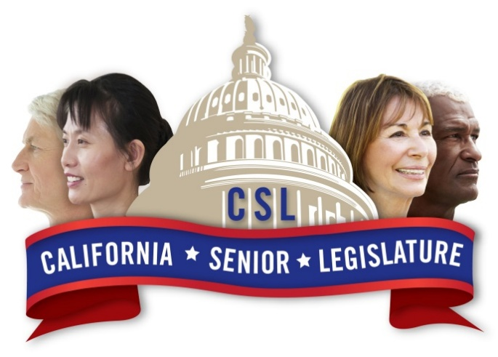

Dedicated to preserving and enhancing the quality of life for older Californians and their families.
CSL Elections
- Are you 55 or older?
- Involved and aware of senior issues in your local area?
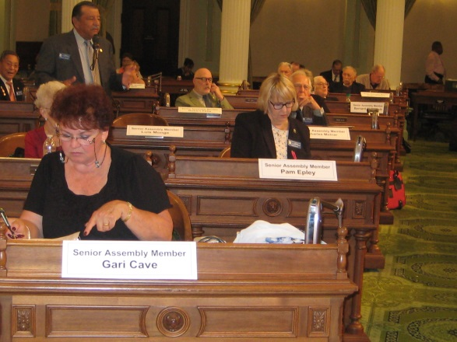
- Driven to make a difference in the lives of aging Californians?
- Willing to volunteer?
- Interested in representing your local community at the State Level?

If you answered Yes, visit the California Senior Legislature website at www.4csl.org or ask your local Area Agency on Aging (AAA) for a CSL election packet to learn more. Election packets are due to your local AAA office no later than March 31, 2026.

